Git – the simple guide: <http://rogerdudler.github.io/git-guide/>

**gitHOW TO USE GITHUB**

1. **Create a Github account.**
2. **Create a repository:**

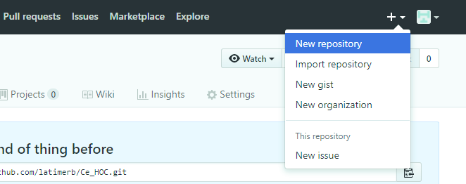

1. **Make a Git repository in the top level directory of the project you want to put on GitHub:**

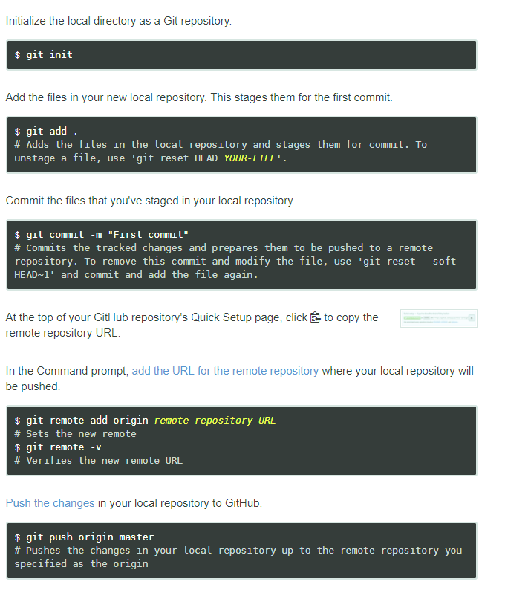

**HOW TO CLONE A REPOSITORY**

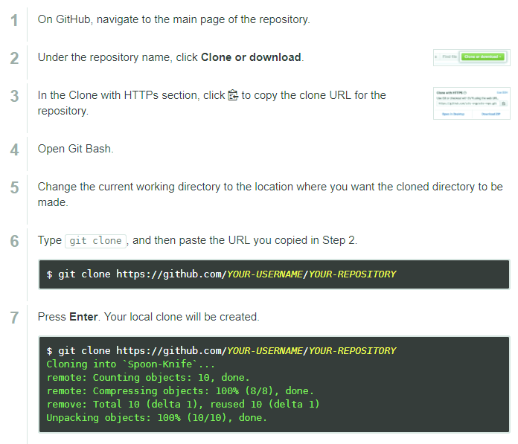

**git status (lists the new files that were created**

**git reset - - hard (will undo changes to cloned files that were changed, will not affect new files)**

**TO REPRODUCE THE ENTIRE DIRECTORY STRUCTURE AT THE WEB GITHUB from the main directory, i.e., copy all the repositories to the local directory, overwriting everything there, issue the following command from the local git directory:**

for d in ./*/ ; do (cd "$d" && git reset --hard && git pull); done